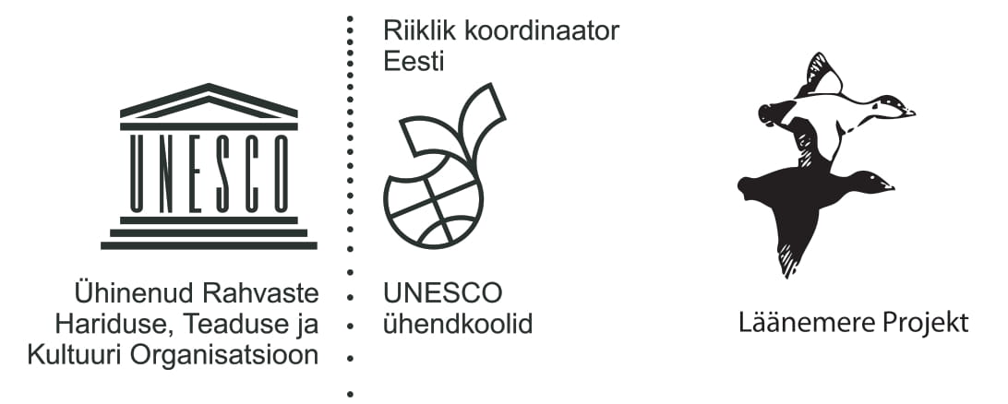
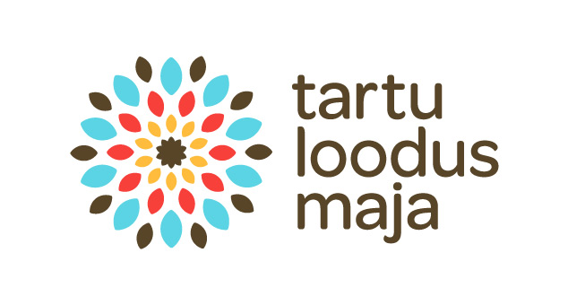

UNESCO BSP
Riverwatch in Estonia
2021 Report
Riverwatch programm in Estonia is jet in renewing protsess. In 2021 all participated groups jused Google form https://bsp.teec.ee/gforms/river_ee.html
In spring 2021 in riverwatch program participated 3 schools with 3 groups on 3 river in different parts of Estonia. Program was officialy opend and new protocol was in use, but it still need complementing.
Participated schools:
1. Tartu Kristjan Jaak Petersoni Gymnasium:

1 observation on Emajõgi river in Tartu at 11.05.2021. Teachers Helgi Muoni and Tiina Sõber, participated 10. grades students.
2. Alatskivi School:
1 observation on Alatskivi river at 31. 05.2021. Teacher Ingrid Laur, participaed students fron 5. grades.
3. Kadrina Secondary School:
1 observation on Loobu river at 1.06.2021. Teacher Siret Pung.
Results
All observations were done with nice wether without rain and with no or moderate wind conditions. Observation spots were in towns, with significantly great human impact in surroundings.
Observations included fysical, chemical parameters, watwerplants and animals.
Emajõgi river was estimated in normal quality as far as it can be decided by plants and bottom invertebrates findings. Loobu river and Alatskivi river were in good or very good condition, biodiversity was very big in Loobu river. Unio crassus was found in Alatskivi river.
Chemical mesurments has been taken in Emajõgi river and Loobu river. These data also show mostly no alarming results, but normal conditions. Only amonium (NH₄⁺) content in Emajõgi was very high, 2 mg/l, it is hard to say, was it due to real conditions or due to mesouring equipment situation.
Some impact of corona period and restrictions and complicated school-year on 2020-2021 is possibly seen also to riverwatch program, but still some observations were done.
Thaks for all observers and participated teachers! We hope, Riverwatch programm give some support for enthusiastic teachers to do some outdoor observations, teaching and learning practical mesouring skills, possibility for students in new way for making acquaintance with hometown river.
Hoping even more groups to join the program in next season.

With very best,
Anneli Ehlvest
Riverwatch coordinator in Estonia

